# Sri Lanka Institute of Information Technology

# SE3050 – User Experience Engineering

# Milestone 03: Verify key users flows

**Group:** Native Coders



IT21118340 Kumarathunga S. A. D. S.

IT21291364 Rashen W.G.M

IT21267772 Kumanayake I. A.

IT21388934 Siriwardhana S.M.R.R.

## IT21118340

Fail Points

1. Tutors mention in the interview that they prefer to share study materials.
   * + Change the user flow by, modifying input details for the study materials.
2. Tutors mention in the interview that they want add a thumbnail image for the study materials.
   * + Change the user flow by, adding a new step to upload a thumbnail image.
3. Students mention in the interview that the don't prefer to buy study materials.
   * + Change the user flow by, removing the buying and payment processes and adding downloading process.

Previous User Flow – Tutor

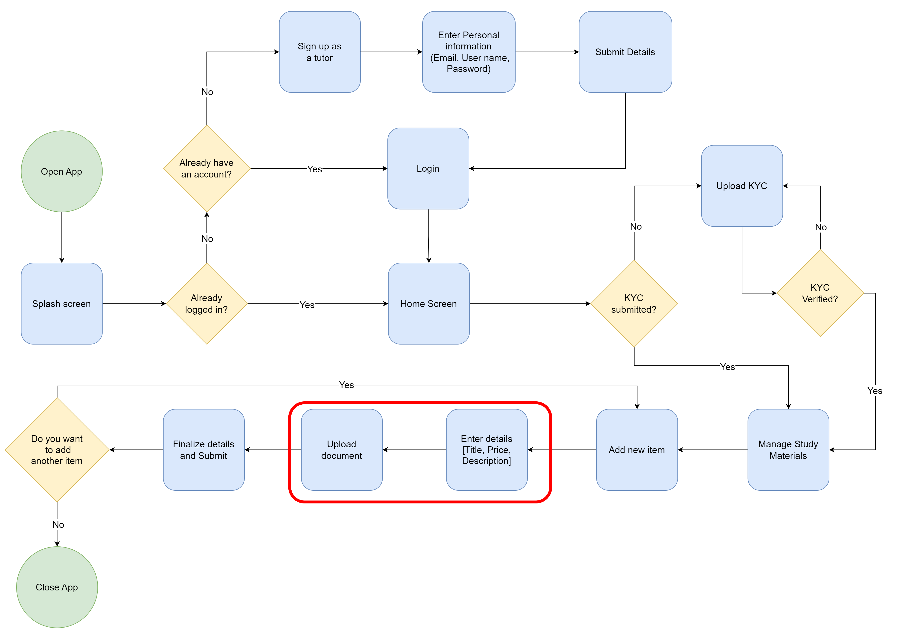

Modified User Flow – Tutor (Fail points 01 & 02)

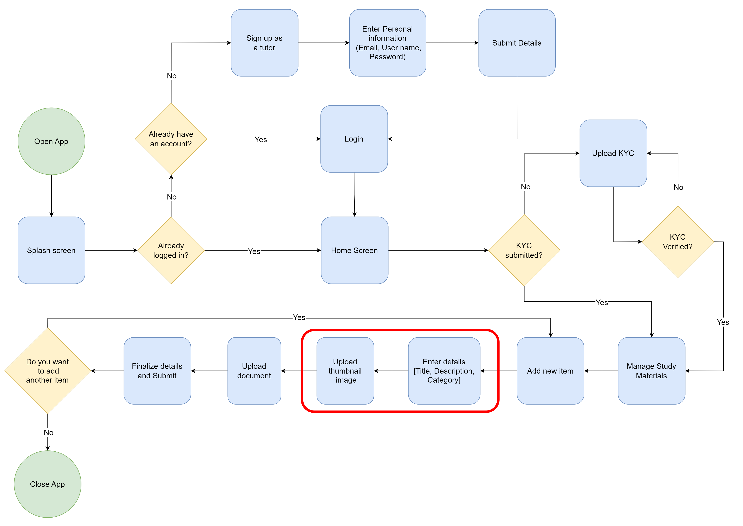

Previous User Flow – Student

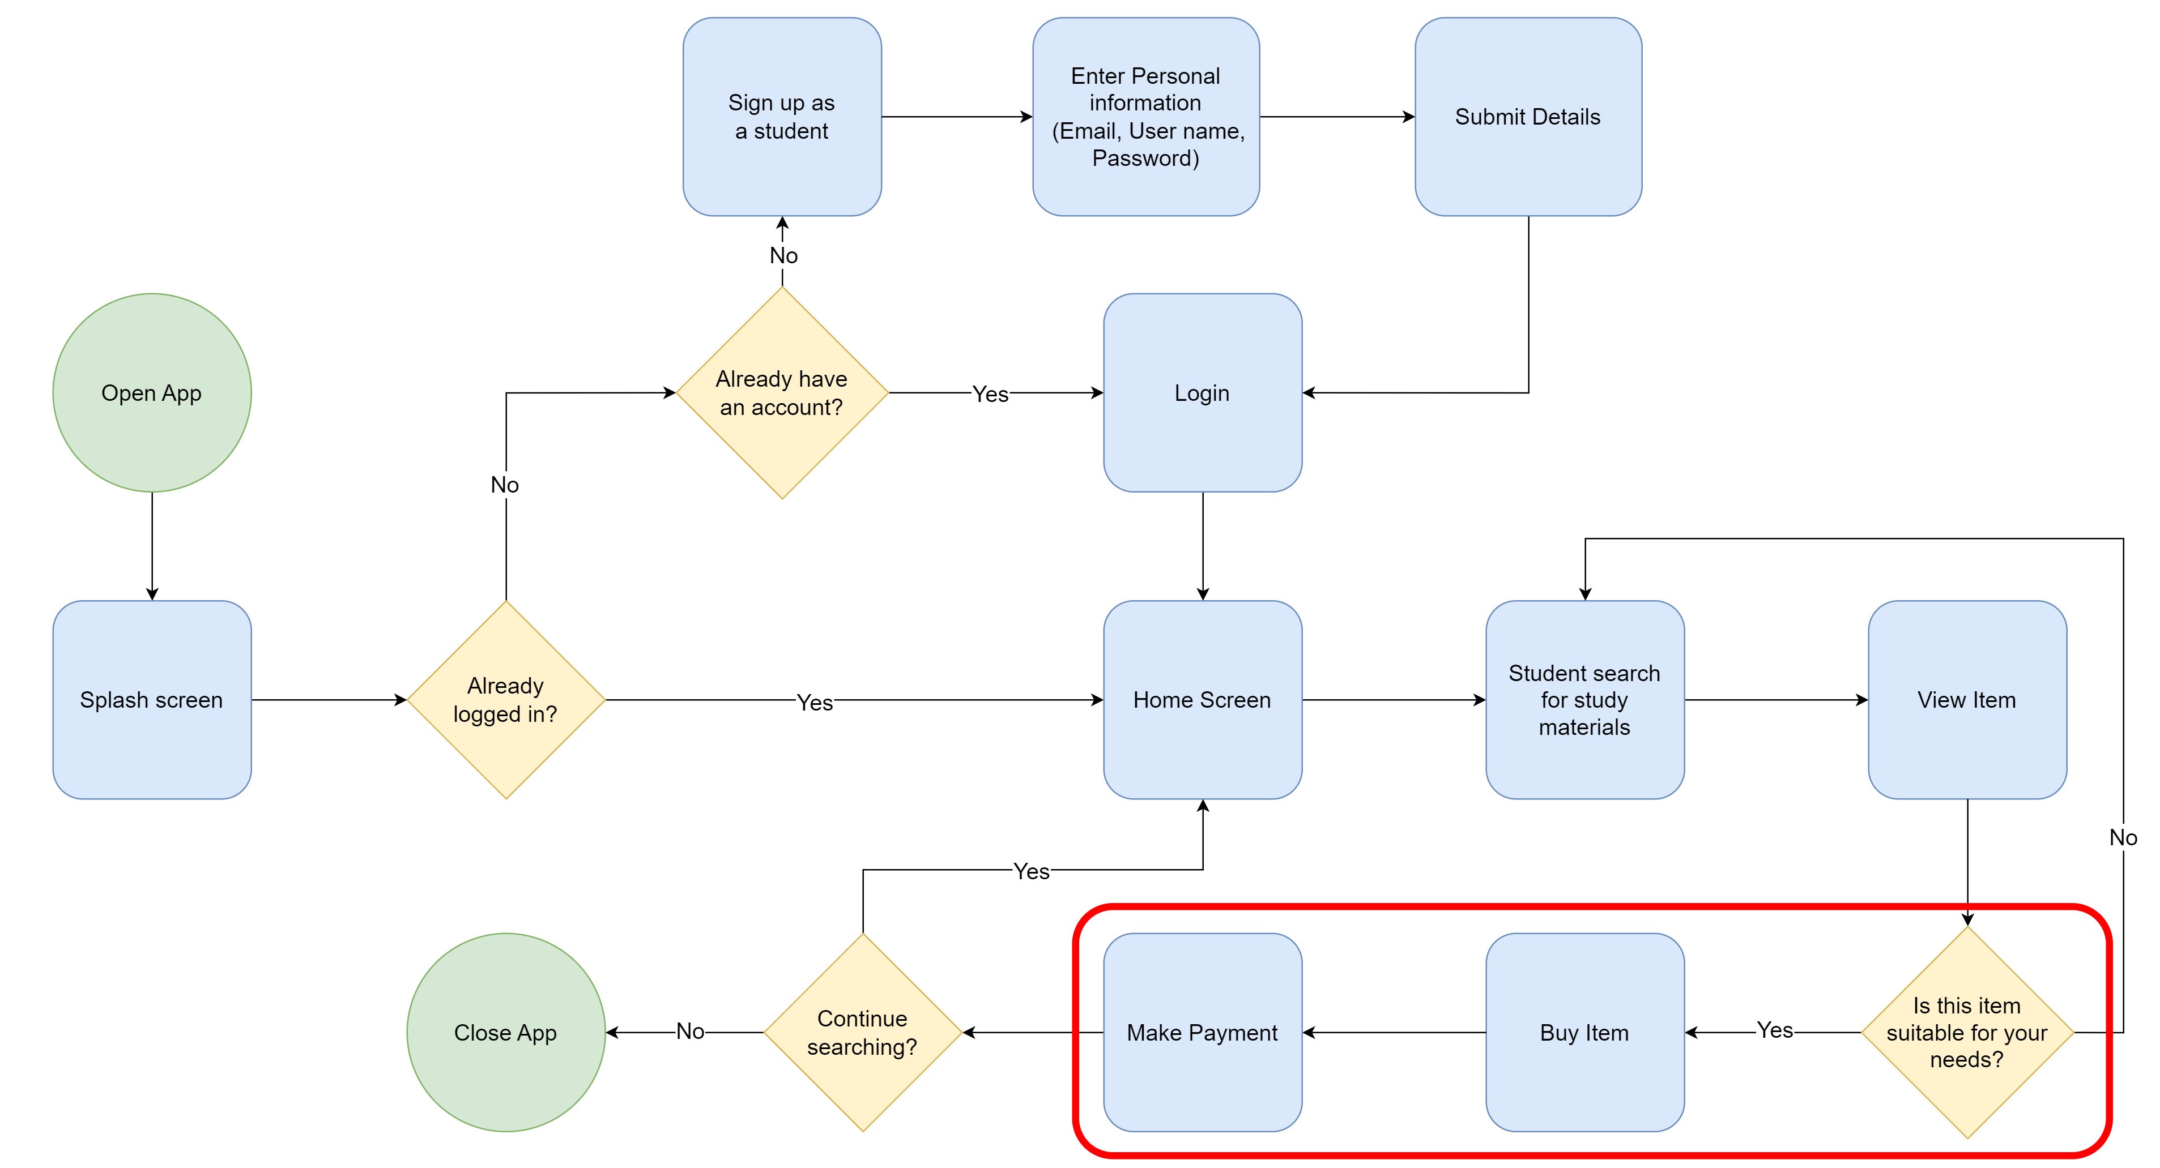

Modified User Flow – Student (Fail point 03)

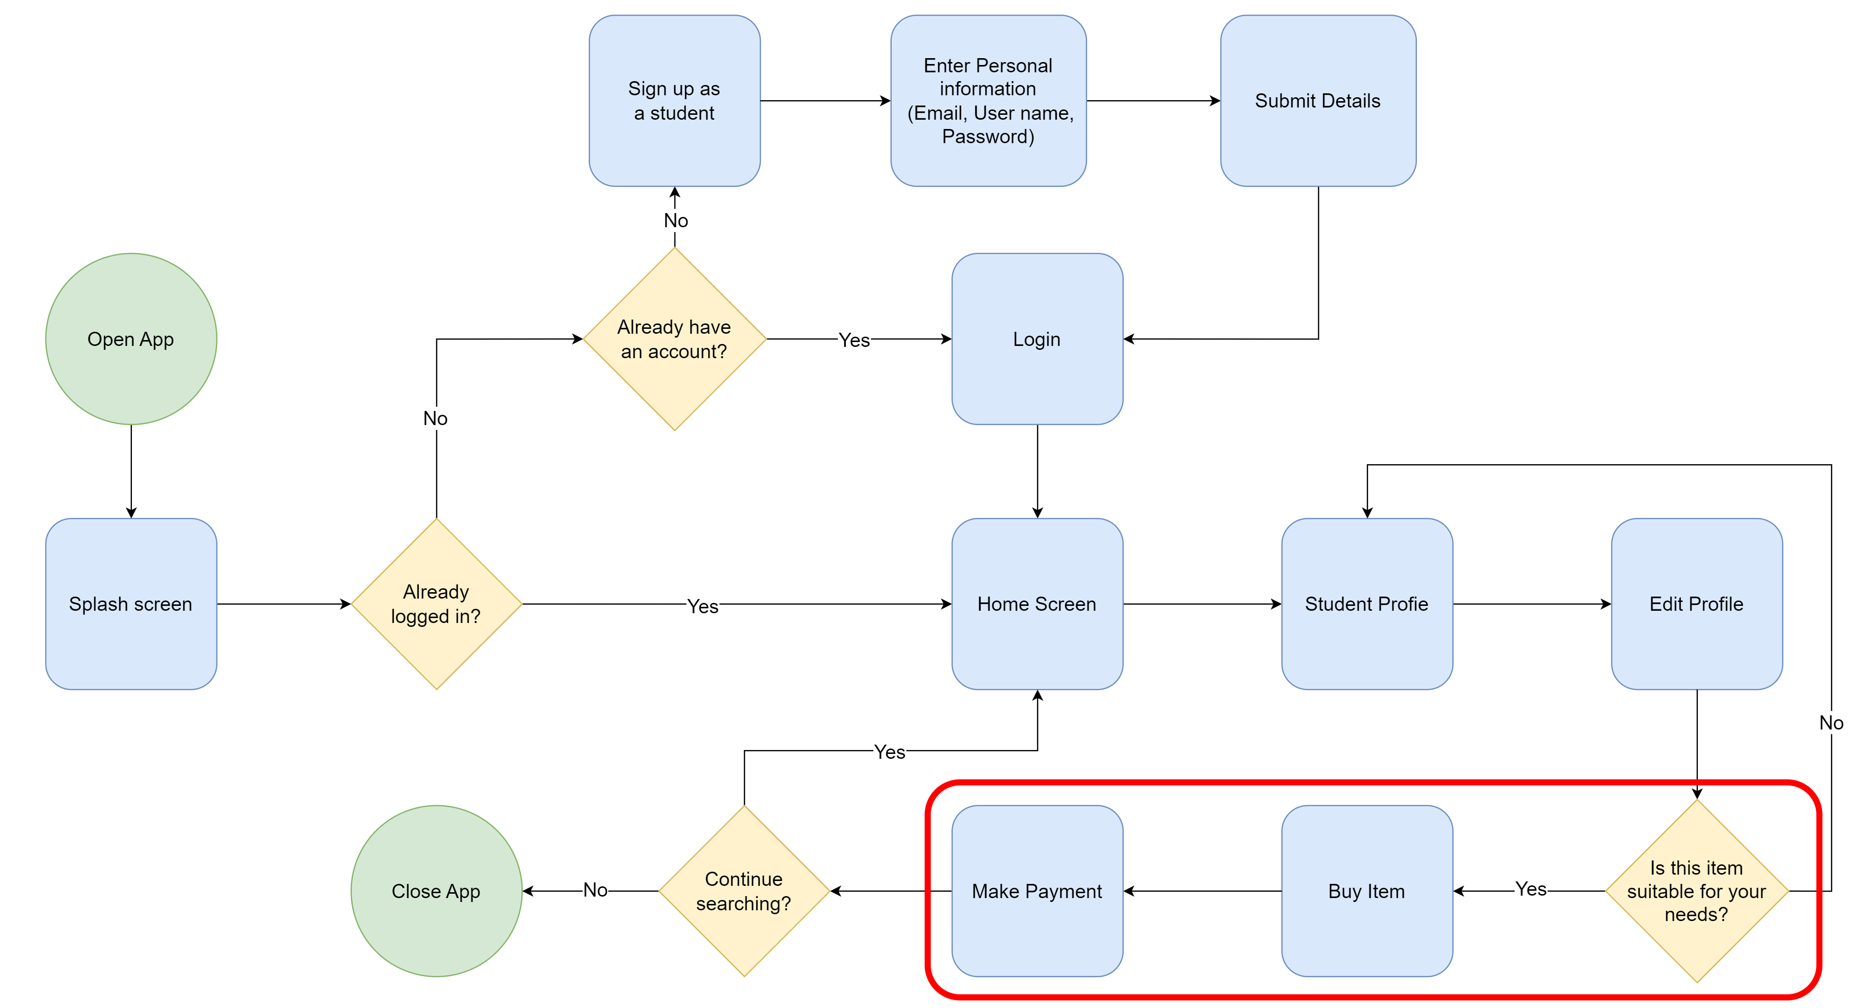

## Other User Flows

Tutor → Update study materials

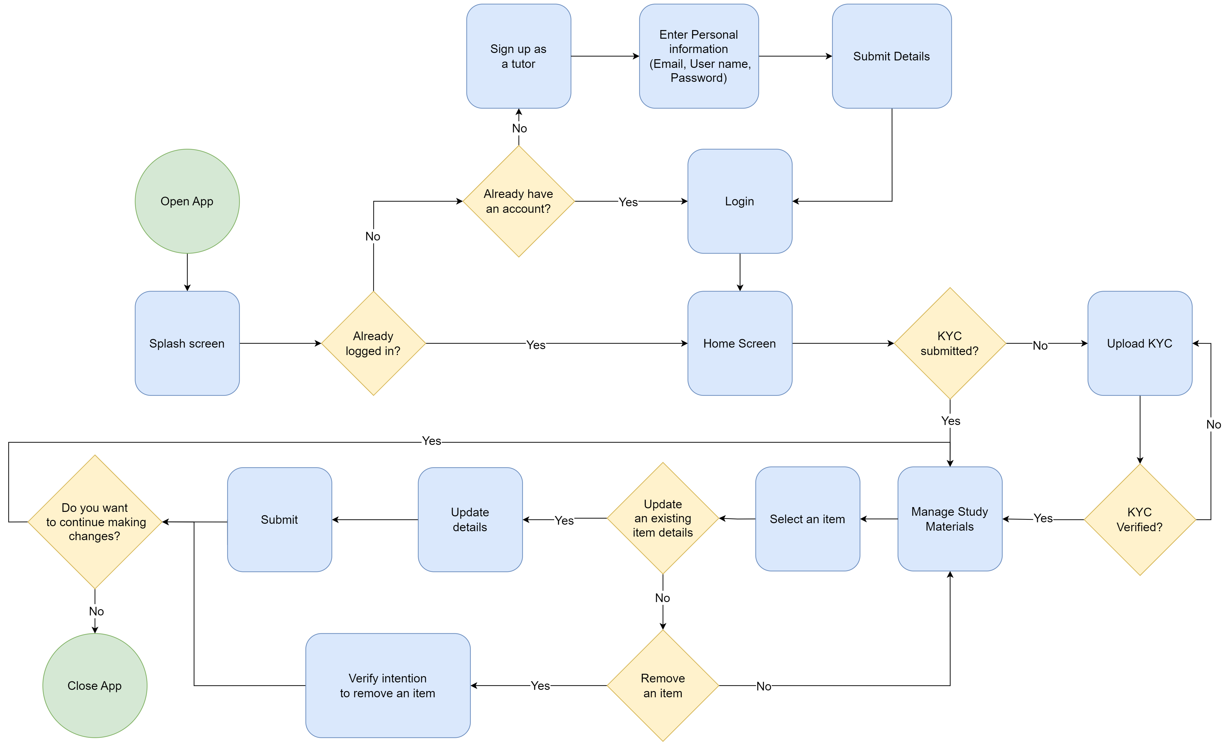Student → Update profile

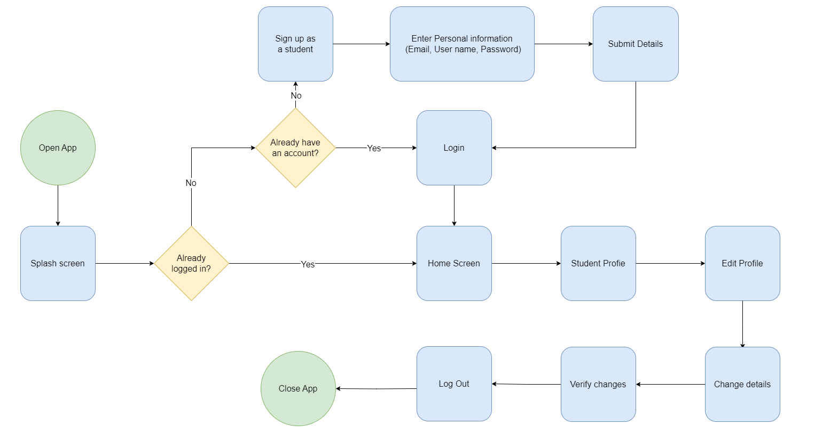

## IT21291364

Fail Points

1. Tutors asked to make the registration process shorter
   * + Change the user flow by, removing the path where user needs enter OTP, to register to the app
2. Tutors asked to make the login process shorter
   * + Change the user flow by, removing the path where user needs to fill a captcha, to log into the app

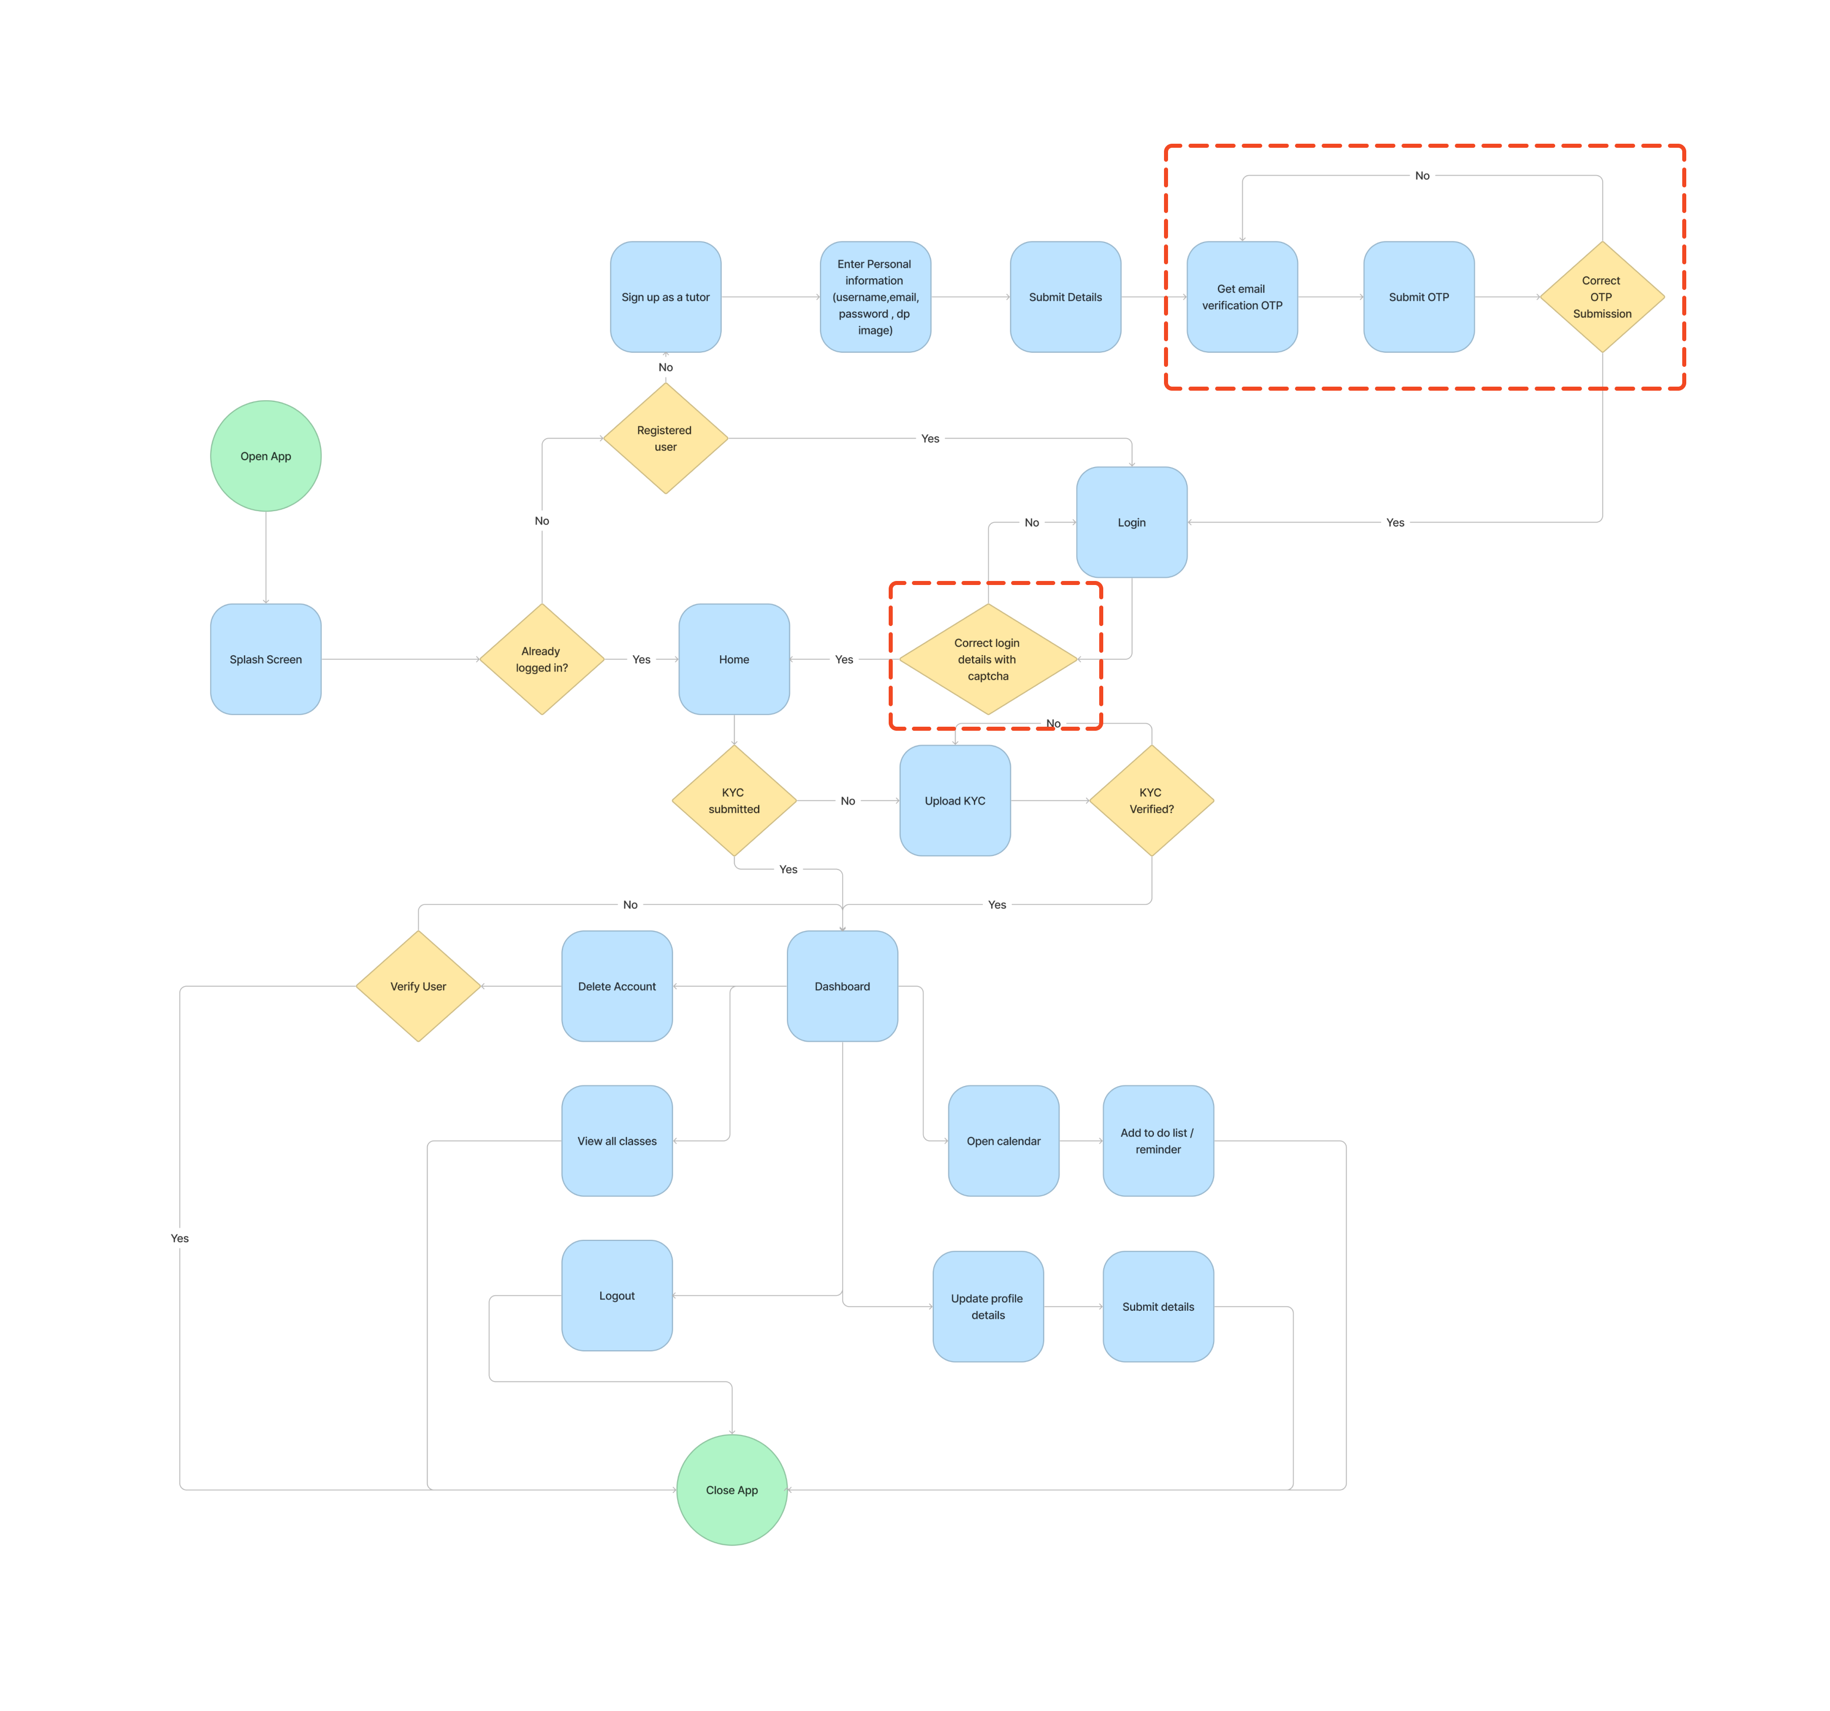Previous User Flow - Tutor

Modified User Flow – Tutor (Fail points 04 & 05)



Other User Flows

Tutor → Manage tutor (With reset password feature)



## IT21267772

Fail Points

1. Students asked for a feature that allows them to view a the reasons for rejection
   * + Change the user flow by, adding the path where user can view reason for rejection
2. Student asked for a feature that allows them to enter additional details when requesting the session.
   * + Change the user flow by, adding the path where user can enter additional details

Previous User Flow - Student



Modified User Flow - Student



Other User Flows

Student → Rate Tutor



Student → Cancel Session



## IT21388934

Fail Points

1. Tutors mention in the interview that they want to select the specific category when publishing the class
   * + Change the user flow by, expanding the *add class details* step.
2. Tutors mention in the interview that they want to add multiple time slots for a class
   * + Change the user flow by, expanding the *set sessions* step.

Previous User Flow – Tutor

Modified User Flow – Tutor (Fail point 09 & 10)



Other User Flows

Tutor → Accept or decline session request

